**PART ONE**

* Write the instructions to draw a red square (20 x 20) and above it a blue circle of radius 25.
* Write a new instruction to calculate the tax (15%). You must receive as an argument the cost of the product.

def tax(cost):

**PART TWO**

**PROBLEM 1**

Write an instruction to draw what is on the left side. *def dessiner (posx, posy, texto).*

Call the instruction dessiner to draw what is on the right side.

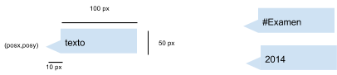

**PROBLEM 2**

Write an instruction that draws the following def dibujarLentes (cx, cy). cx and cy represent the center of one circle.

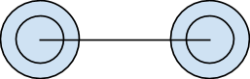

**PROBLEM 3**

Write a program to ask the user a word and then print the first letter of the word.